

SKYNET 3D V2.3.2 (Marlin RC8 Bugfix)

<https://www.facebook.com/skynet3ddevelopment>

<http://www.ebay.co.uk/usr/skynet3dmods>

<https://www.facebook.com/groups/OFFICIALAnet3DprinterSupportGroup/>

<http://3dprint.wiki>

**\*\*\* Credits ***(in no particular order)**

Marc Hannappel – OderWat – Justin + Felix – Hillbilly Wilson– XyGax

You guys have made my visions real . so many thanks 😊

Also a huge thanks to those of you contributing to support on the groups (ben-leo etc)

And all who support the project with lovely feedback and donations. I really do appreciate all of you 😊

**\*\*\*Disclaimer\*\*\***

I (scou) am totally not responsible if “you” kill your printer when you modify it from its stock form.. you do so at your own risk.. if you hurt yourself or kill your neighbours cat.. thats on you too ;) otherwise .. have fun !

This guide will deal with the firmware aspect of the install process. If you need help with wiring your sensor please see the wiring diagrams within the skynet download. If you need anymore help – head over to the facebook group (2nd link at the top of this page). This guide also assumes that you have already had your printer set up with the default anet firmware prior to installation. It also assumes that you have already done some printing on your machine prior to install. This rules out any mechanical problems when people contact me with questions. If you require any assistance with anything non- firmware related then head over to the Anet A-series Facebook group as there are many members who can help out- rather than bombarding me with questions.

We are going to assume that you have already downloaded the firmware package. So drag this to your desktop to make the process easier and make sure all files from the download are unzipped and ready to use! Make sure you look around the files and get to know where things are because we will obviously be refering back to most of it throughout this tutorial.

Ok step one – **FIGURE OUT WHAT TYPE OF PRINTER YOU HAVE**

Many users of the previous version have run into issues where they basically don’t have a clue what printer they have or what lcd they have or weather this firmware will work on their anet main board- well this part is hopefully going to make that process a little more simple.

The a2 a3 a6 and a8 printers all have the same mainboard controller.. theres slightly different revisions of this controller- some with different power plugs and some with potentiometers for adjusting stepper current but theyre all basically the same thing. You also should know which printer you purchaced- weather that is an A2 A3 A6 or A8..

Lcd- now this is where people run into problems; there is 2 main types found on anet printers.

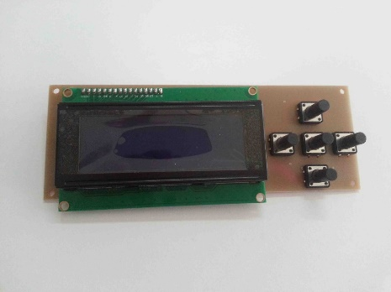**Theres the lcd 2004… aka 5buttonkeypad**

This lcs is found on the A8 and some A2 printers.

**Theres also the LCD12864 aka a6lcd/ full graphics lcd /**

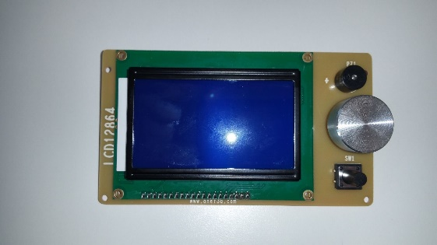 This lcd is usually refered to as the full graphics display and is found on the A6 and some A2 printers.

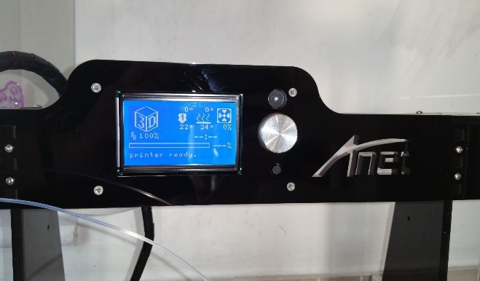You can mount the A6 lcd12864 to an A8 printer with one of my frame mods found on my ebay which in my oppinion is one of the best upgrades simply because I hate those buttons on the lcd2004.

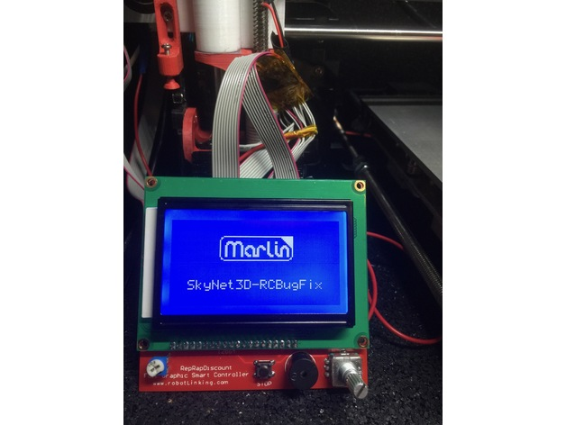.

**The A6 LCD12864 (above) is not to be confused with the RepRap Discount LCD12864(left)**

The a6 lcd can be installed on any anet printer without modification where as the reprap discount lcd will require you to modify cables and firmware in order to run it! Information and guide can be found on OderWat’s thingiverse here…

<http://www.thingiverse.com/thing:2103748>

obviously installing the A6 lcd on an A8 is the easiest method and will essentially be the same phycical lcd display

NOW THAT WE ARE FULLY AWARE OF WHAT LCDS ARE WHAT – THIS BRINGS ME ON THE NEXT SECTION.

***CHOOSING THE CORRECT PROFILE***

If you open up the skynetv2.3.2 firmware folder you will see another folder labled Configuration Profiles!. Inside this you will see a list of folders labled with each 3d printer that we currently have profile presets for. And inside this we have folders containing each individual pre-configured configuration.h file along with the necessary .stl sensor mount to go along with said profile.

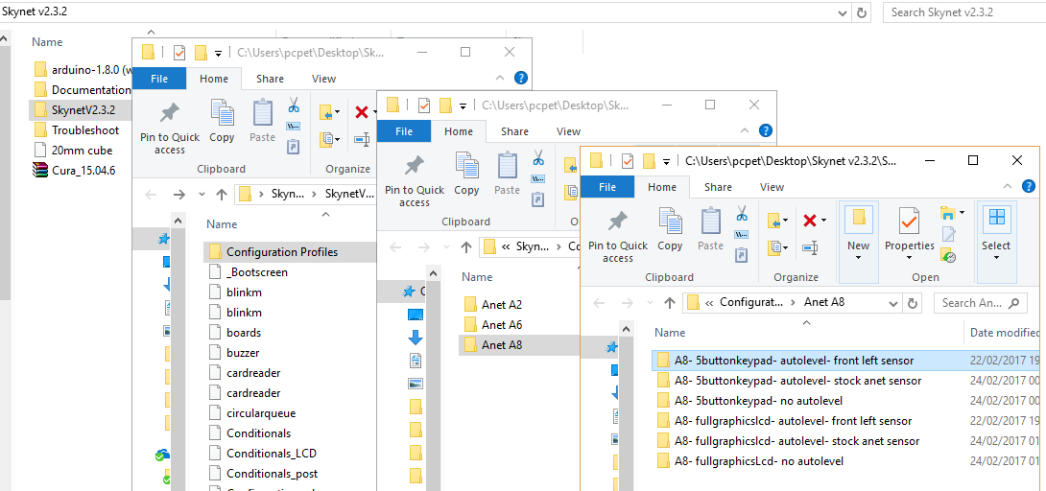

Below is the format in which all the profiles will be layed out and it’s the “configuration.h” that will later be copied into the main firmware directory.

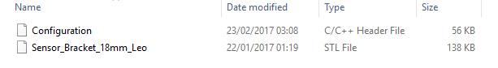

If you are using a non autolevel profile you can skip this next step!

***Print the required sensor mount .stl and install your sensor on your printer***

As I have already stated above – this guide assumes that you already have a fully functional Anet 3d Printer so this shouldn’t be a problem. If you are installing skynet because you cant print using stock firmware then you are going about this whole process all wrong and I strongly suggest you seek advice from one of the facebook groups in order to grasp the basics before moving ahead.

If you are struggling with installing your sensor or wiring up the electronics properly- may I suggest either purchacing one of my premade- plug and play sensors or one of the level shifer chips from my ebay shop to make installing the sensor as easy as possible. There is also a sensor_options.pdf to aid with wiring in the diagrams and images folder of this download.

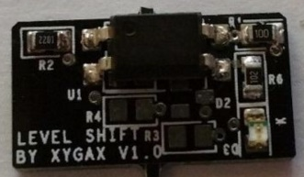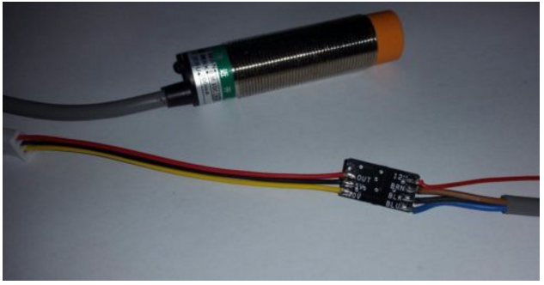

OderWat has also included support now for the bltouch style sensors with a instructional guide here <http://www.thingiverse.com/thing:2091529>

You can test out functionality of the sensor using the stock firmware by either;

*Raising the nozzle high enough so that if things go wrong you leave yourself enough time to kill power to the printer- run a home all axis command and using a metal object – try to stop the printer by making the sensor detect said metal object.*

Or…

*You could use the M119 command to test functionality of the sensor- again using a metal object like a screw driver or spanner.*

Just be careful and use your common sense at this stage to avoid nozzle crashes ***Make sure the sensor is working before installing the firmware!***

ok- you should now be ready to install the firmware onto your printer. By this stage you should already have the required drivers for your printer installed (CH340) and be able to print using the stock firmware over USB.

If you are unable to connect to and print from your printer using the usb then you need to head over to the Anet A-series facebook group and ask for some help.

**Installation**

Select the the required profile and copy the configuration.h file from that profile into the main skynet3d firmware directory as showed in the pictured below. 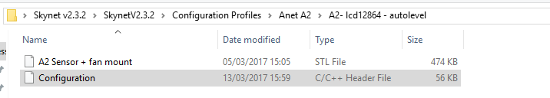

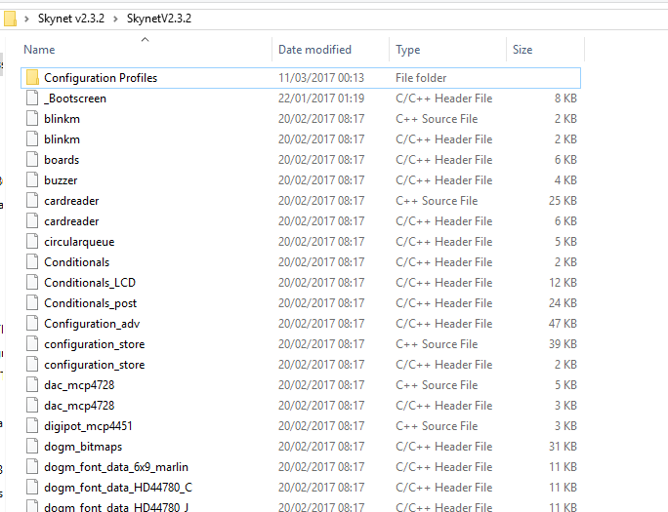

🡨 This picture show the firmware directory without the configuration.h file inside it.

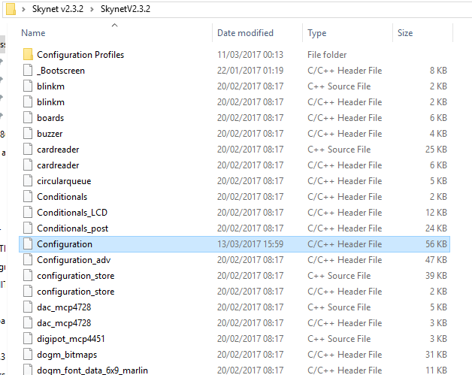

🡨 This picture shows the firmware directory with the configuration.h file inside it. If you struggle to paste in the file -try ctrl+v

Open the arduino application 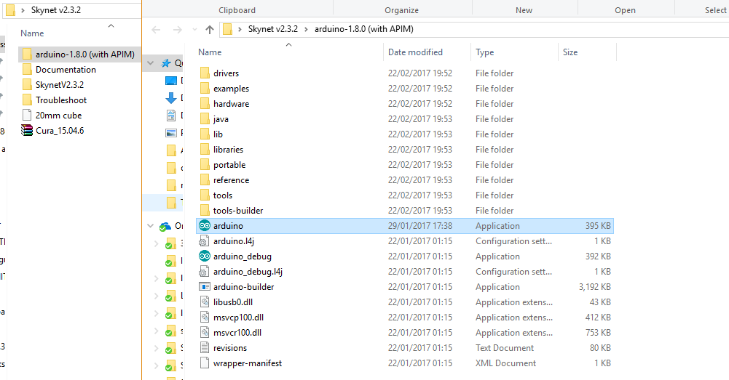

If the windows security alert comes up- click “Allow access”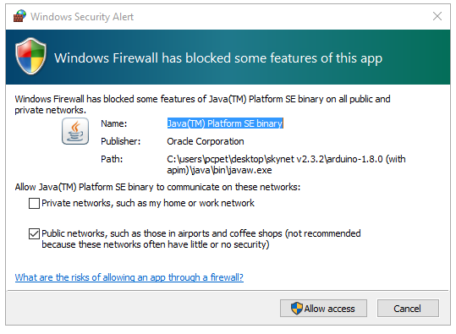

Now you will be presented with the arduino ide application

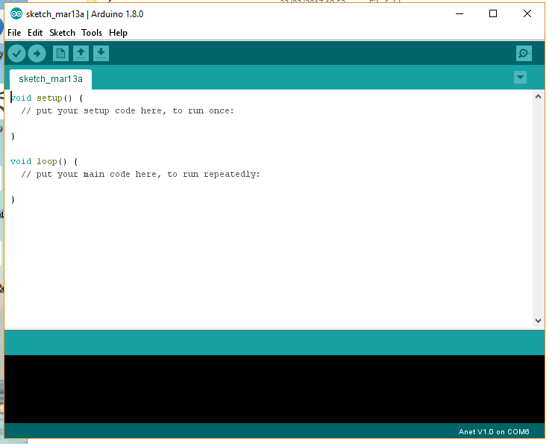

we are going to change the ‘board , port and programmer’ options in order to allow arduino ide to talk to- and upload the firmware to our printer.

But first go to “Device Manager” on your computer and then go down to Ports(COM & LPT) and check what com port your printer is on (USB-SERIAL CH340). Mine is COM6 but yours may be different.

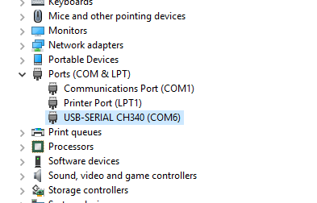

if this isnt showing up in your device manager you may need to reinstall the ch340 driver. Included in the Troubleshoot folder of the download 😊

Go to “Tools” and change the “Board” “Port” &“Programmer”as they are show below but make sure to pick the correct com port if yours is different to mine.

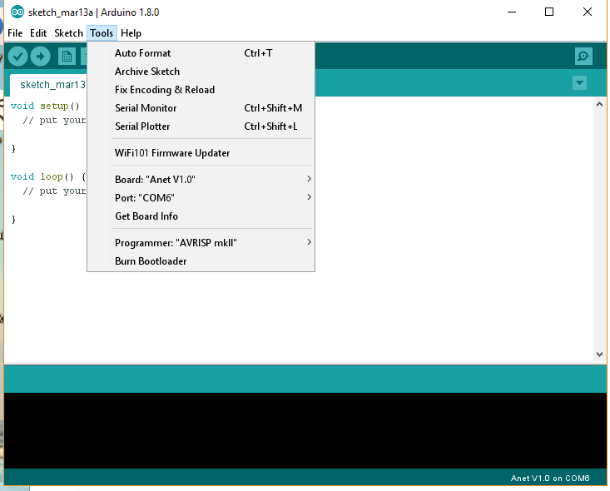

Now go to “File” “open” and navigate to the SkynetV2.3.2.ino file in the firmware directory and click “Open”.

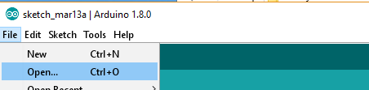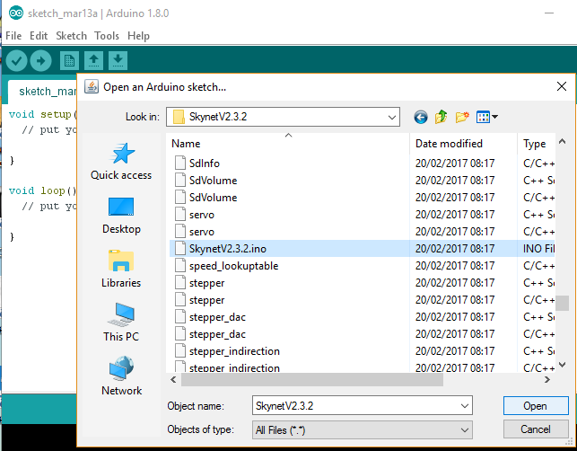

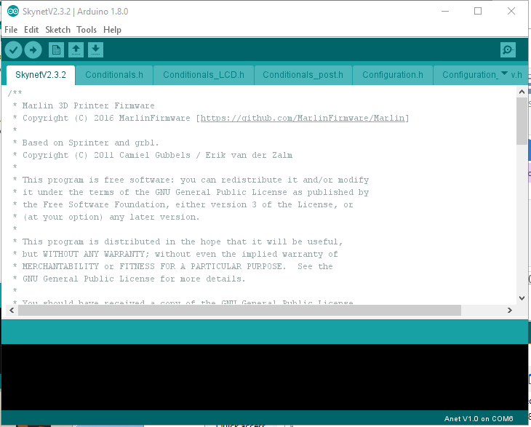A new Arduino window will open with the first tab on the page being SkynetV2.3.2

## if you look at the tabs in this window.. make sure “configuration.h” is there otherwise go back and choose a profile!!

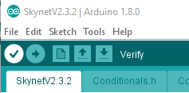Click on the “Verify” button (tick) to test compile the firmware.

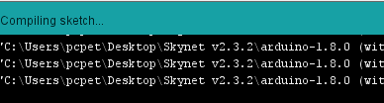

Wait for the program to finish compiling.

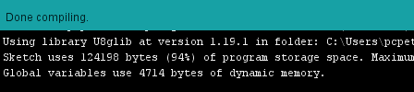

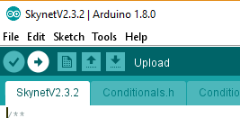Good now you can “Upload” the firmware to the printer using the button next to the tick

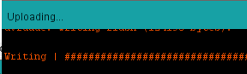

Once it says “Done uploading.” Then thats it

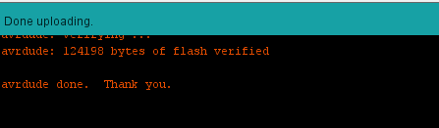

Congratulations !!! you have now successfully installed skynet onto your printer!

Your printer should now say.. Skynet3D ready on the display.

If the printer does not display anything.. make sure you have selected the correct profile for your printer.. as installing an Lcd12864 profile on a stock A8 that hasn’t had the lcd mod WILL NOT WORK!!!

*If you are getting the u8glib error which causes the upload to fail. Go to Sketch, Include Library Manage Libraries and type u8glib in the ‘’filter your search’ bar. Then scrol down to the U8glib by oliver and install the latest version from there!*

If you are getting other errors or you need to install skynet using a different operating system then go to the Anet A-series facebook group and do a search or ask people for help .. It can be done but I personally only use windows so wont be much help. Same goes for messaging me on the skynet page about how to install using mac or linux- I have no idea!

If you have a non autolevelling profile installed then you are done. CONGRATULATIONS!!! You do not need not follow the Z offset Tutorial and may go forth and print some awesome stuff!

For you autolevellers out there – close this guide down and open up the Auto Bed Levelling Guide and we will carry on with the setup of the slicer and the offset to get you printing like a pro!

Final note!

If you choose to install different carriages or e3d upgrades on your printer.. make sure you get the details of what to modify in the “configuration.h” from the creator of that mod. Im simply not going to know the offset setting etc.. for every possible mod from thingiverse and you should be aware of this before installing the firmware or your chosen mod!

Thanks for choosing Skynet3D. HAPPY PRINTING!!